**Pressure Detection Project**

**Mastering Embedded Systems Diploma**

[www.learn-in-depth.com](http://www.learn-in-depth.com)

First Term (Final Project 1)

**Eng. Amr Esaam Mohammed Zidan**

My Profile: <https://www.learn-in-depth.com/online-diploma/amresaam1342000%40gmail.com>

Contents

1.Case Study............................. 2

•Requirements................................... 2

•Assumptions................................... 2

•Versioning................................... 2

2.Method............................. 3

Software Development Lifecycle and Software Testing Lifecycle 3

3.System Requirements............................ 4

Requirement model 4

4.Design Space Exploration............................ 4

5.System Analysis............................ 6

•Use Case Diagram.................................. 6

•Activity Diagram.................................. 7

•Sequence Diagram.................................. 8

6.System Design............................ 9

•Block Diagrams.................................. 9

•State Machine Diagrams.................................. 10

Pressure Sensor 10

Main Controller 11

Alarm Monitor 12

Alarm 13

•C Codes.................................. .. 14

Pressure Sensor 14

Main Controller 15

Alarm Monitor 16

Alarm 17

Main 18

Code Building Tools 19

Startup code 19

Linker Script 19

Makefile 20

•Simulation...................................... 21

Pressure equals or larger than threshold 21

Pressure less than threshold 22

Software Analysis 23

.map file 23

Symbol Table 23

Section Table 24

# Case Study

## Requirements

The client requires a system with the following specifications:

1. Pressure controller informing the cabin crew when pressure exceeds 20 bars.
2. The informing method is an alarm operating for 60 seconds.
3. Keep track of the measured values (optional).

## Assumptions

The following assumptions are made:

1. No setup or shut down for the microcontroller.
2. No maintenance for the microcontroller.
3. Neither the pressure sensor nor the alarm fails
4. No power cuts for the microcontroller

## Versioning

The possibility of storing pressure sensor readings might be included in a future version.

# Method

## Software Development Lifecycle and Software Testing Lifecycle

The (SDLC) and (STLC) will be approached based on the V-Model.

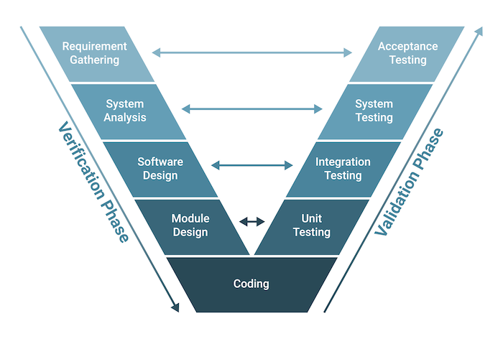

Requirements Gathering and Analysis: The first phase of the V-Model is the requirements gathering and analysis phase, where the customer’s requirements for the software are gathered and analyzed to determine the scope of the project.

Design: In the design phase, the software architecture and design are developed, including the high-level design and detailed design.

Implementation: In the implementation phase, the software is actually built based on the design.

Testing: In the testing phase, the software is tested to ensure that it meets the customer’s requirements and is of high quality.

Deployment: In the deployment phase, the software is deployed and put into use.

Maintenance: In the maintenance phase, the software is maintained to ensure that it continues to meet the customer’s needs and expectations.

The V-Model is often used in safety-critical systems, such as aerospace and defense systems, because of its emphasis on thorough testing and its ability to clearly define the steps involved in the software development process.

# System Requirements

## A diagram of a computer flowchart Description automatically generatedRequirement model

# Design Space Exploration

Microcontroller: one stm32f103c8t6 SoC will be used as it meets all the needed technical requirements such as: suitable processor, acceptable flash memory size and small size as well as being cost efficient.

Overview: The STM32F103C8T6 is a medium density performance line, ARM Cortex-M3 32bit microcontroller in 48 pin LQFP package. It incorporates high performance RISC core with 72MHz operating frequency, high speed embedded memories, extensive range of enhanced I/Os and peripherals connected to two APB buses. The STM32F103C8T6 features 12bit ADC, timers, PWM timer, standard and advanced communication interfaces. A comprehensive set of power saving mode allows the design of low power applications.

**Features:**

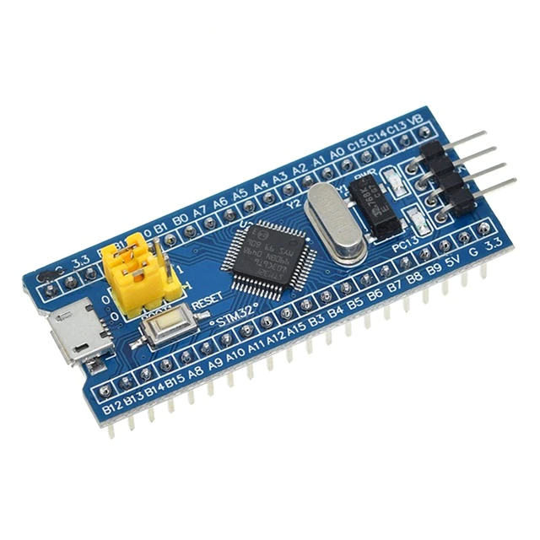Operating voltage range from 2V to 3.6V

64Kbytes of flash memory

20Kbytes of SRAM

CRC calculation unit, 96bit unique ID

Two 12bit, 1μs A/D converter (up to 10 channels)

7 channel DMA controller, 3 general purpose timer and 1 advanced control timer

37 fast I/O ports

Serial wire debug (SWD) and JTAG interfaces

Two SPI, two I2C, three USART, one USB and one CAN interfaces

Ambient operating temperature range from -40°C to 85°C

# System Analysis

## Use Case Diagram

## Activity Diagram

## Sequence Diagram

# System Design

## Block Diagrams

## State Machine Diagrams

### Pressure Sensor

### Alarm Monitor

### Alarm

## C Codes

### Pressure Sensor

.c file

.h file

### Main Controller

.c file

.h file

### Alarm Monitor

.c file

.h file

### Alarm

.c file

.h file

### Main

.c file

## Code Building Tools

### Startup code

### Linker Script

### Makefile

## Simulation

### Pressure equals or larger than threshold

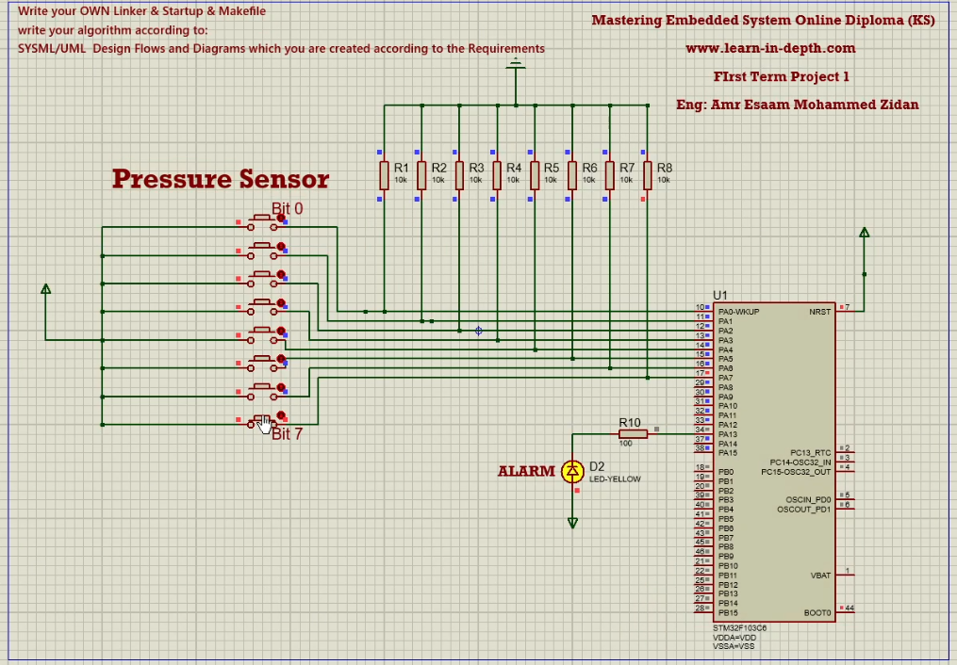

### Pressure less than threshold

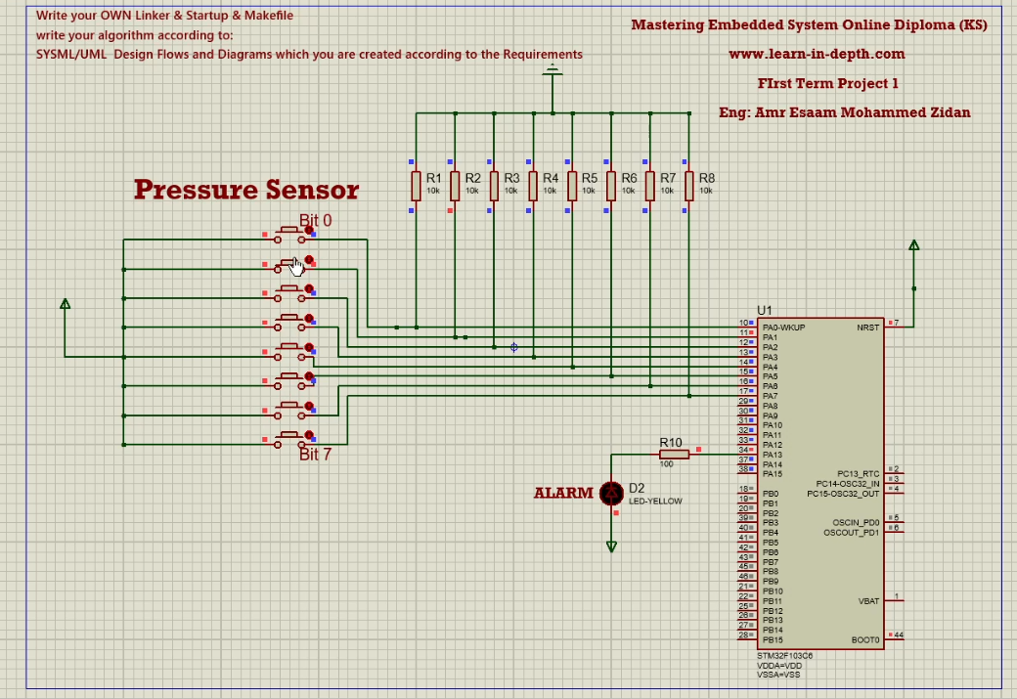

## Software Analysis

### A screen shot of a computer Description automatically generated.map file

### Symbol Table

### Section Table

